Real Capstone
Epilogue 2 — What You Actually Need to Know
Michael Harris
March 2026
The Dangerous Advice
Someone will tell you this. Maybe they already have.
"You don't need to understand software. AI handles all of that now. Just describe what you want and it builds it."
That advice will cost you months. Possibly the product.
I know because I built a working app in roughly 20 hours of focused work — an app that would have taken an estimated 150 to 220 hours using traditional development. AI made that possible. But not because I handed it the wheel. Because I understood exactly what was happening at every step, and I knew when AI was optimizing for the wrong thing.
Without that understanding, I would have spent 200 hours building an app from scratch that Replit agents could scaffold in an afternoon. I would have waited weeks for a platform to fix a deployment problem I didn't actually have. I would have let a server launcher block product progress for a month. And I would have missed two cost optimizations — worth tens of thousands of dollars at scale — that fell out naturally once I understood the system.
None of those outcomes required coding skill to prevent. They required systems literacy. Those are not the same thing.

The Contractor Who Doesn't Pull Wire
A general contractor doesn't do the electrical work. They don't pull wire, install panels, or calculate load capacity. That's what the electrician is for.
But the contractor knows exactly what the electrician is supposed to deliver. They know what a completed rough-in looks like. They know when the work is wrong. They know what questions to ask. They know when the electrician is over-engineering a solution that doesn't fit the project.
If the contractor doesn't know any of that — if they just hand the job over and trust the trade — the project drifts. Costs inflate. Timelines extend. And when something goes wrong, the contractor has no way to see it coming.
You don't need to know how to code. You need to know what the code is supposed to do and why.
That distinction is everything. One is a technical skill that takes years to develop. The other is comprehension — understanding the system well enough to reason about it, catch problems in it, and make decisions about it.
Comprehension is learnable. And it's non-negotiable.

What Happened When I Understood It
The 80/20 Shift
AI told me to build the app from scratch. Full custom implementation. 150 to 220 hours.
I pushed back — not because I could write the code faster, but because I understood what the app actually needed. Authentication, database setup, payments, routing, deployment infrastructure. None of that is product value. That's plumbing. Every app needs it. Platforms like Replit are built specifically to handle it.
The question I asked wasn't technical. It was architectural: what in this system actually creates value? The answer was clear once I framed it that way. The mechanism — the coaching logic, the phase engine, the prompts — that's the 20% that matters. The other 80% is commodity. Let the platform build the commodity.
Timeline dropped from 220 hours to roughly 20. Not because AI got faster. Because I understood the system well enough to direct it correctly.

The Deployment Block — and the Wrong Layer
After weeks of building, the app wouldn't deploy. The error was technical — something about Gunicorn binding to a Unix socket instead of a TCP port. Support tickets went in. Infrastructure escalations followed. The technical explanations kept getting more complex.
A week passed.
Then I stopped trying to solve the technical problem and mapped the system as a simple flow. Customer enters through a door. Receptionist routes them. Security checks credentials. Waiter takes the order. Kitchen prepares the response.
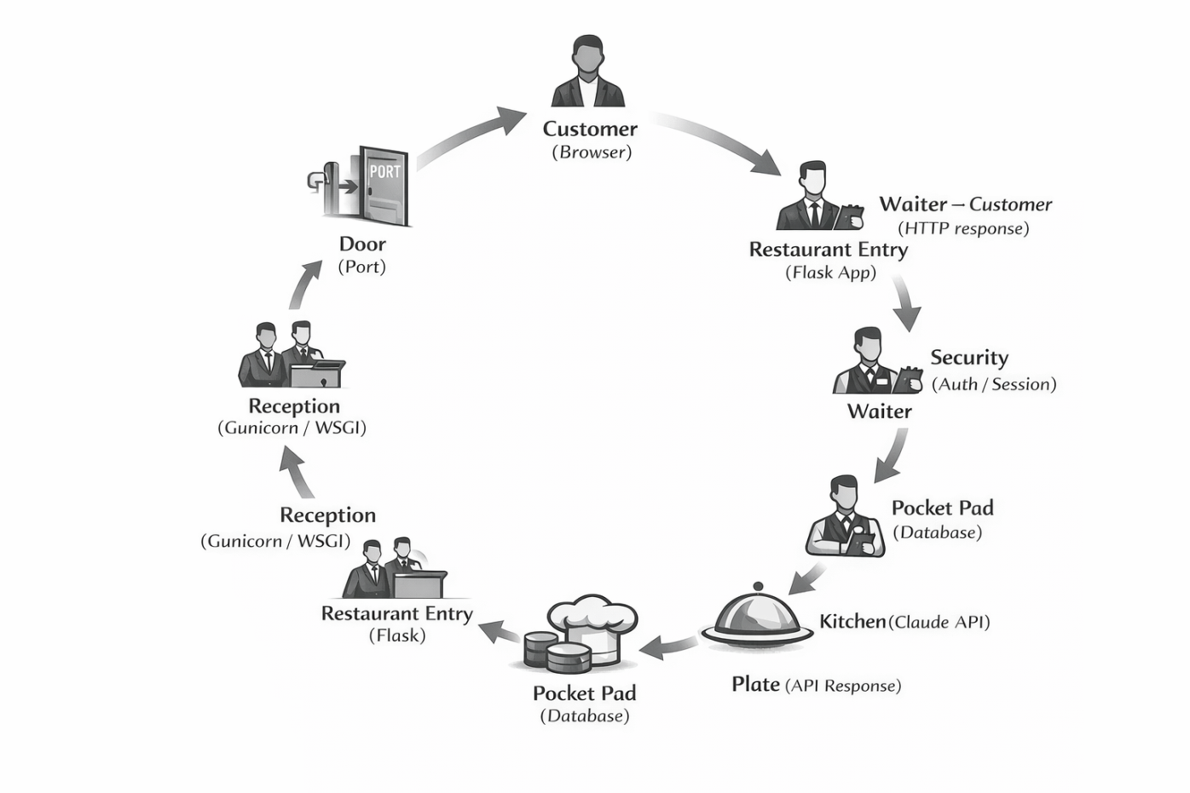
Once I could see the flow, I could see where it was breaking. The door wasn't opening the way the platform expected. Everything else in the system was fine. The constraint was obvious. The solution was two words: python app.py.
I didn't fix this by learning to code. I fixed it by understanding the system well enough that the constraint became visible.
But the deployment fix exposed something more significant than a server launcher swap. It exposed that AI had been confidently optimizing the wrong layer of the system entirely.
The recommendation was Gunicorn — a production web server that adds workers inside a container, handling more requests simultaneously. More waiters in one restaurant. It's standard engineering advice for web apps.
But my app isn't a standard web app. It's an LLM app. Every request spends 2 to 5 seconds waiting for Claude to respond. During that wait the server is essentially idle. Adding more waiters doesn't help when the bottleneck is the kitchen. You can staff a thousand waiters — if the kitchen only cooks 50 meals a minute, the line forms there regardless.
The real scaling constraints for this app, in order: Claude API rate limits, Claude token cost, database throughput. Server concurrency is last on the list. Gunicorn doesn't address any of the first three. It never would have — at any user count.
AI didn't just push premature optimization. It optimized a layer that wasn't the constraint at any scale.
This only became visible once the system was simple enough to see. Component-level thinking — Gunicorn, workers, containers, autoscaling — obscured it. Flow-level thinking — user, server, Claude, database — made it obvious immediately.

What Fell Out When the System Was Clear
Here is the part that surprised me most.
Once the flow was visible, two significant optimizations appeared that neither AI had suggested — not once, across weeks of technical conversation.
The first was prompt caching. Every conversation sends the same large system prompt and phase instructions to Claude on every single message. Without caching, Claude reprocesses thousands of tokens of identical content every turn, for every user. With caching, those static portions are stored and charged at roughly 10% of normal token cost. The estimate for input token savings per session is 30 to 60 percent — real money at scale, and a direct reduction in the primary cost constraint.
The second was threading. Flask's development server handles one request at a time by default. But because each request spends most of its time waiting on Claude, a single server process can actually juggle dozens of concurrent requests if threading is enabled — each one waiting on the kitchen while the waiter takes the next order. One line of code. No additional infrastructure. No extra cost. Delays the need for additional containers significantly.
Both optimizations were obvious once the flow was mapped. Neither required coding skill to identify. They required understanding where the real work was happening in the system.
Understanding the system doesn't just protect you from AI's mistakes. It reveals optimizations the experts missed entirely.
Worth noting: the caching savings estimate Claude initially gave was 60 to 70 percent. A second review put it more accurately at 30 to 60 percent depending on session structure. Even AI's optimism about the fix it missed was slightly overstated. The lesson holds either way — the savings are substantial, and they were invisible until the system became simple enough to see.

The Test That Caught the Failure
AI was going to have me test the prompts manually. Run sessions myself, see how they felt, adjust based on intuition.
I pushed for automated live tests against the real Claude API. Scripted conversation sequences. Measurable outcomes. Eight canonical exit routes, each one verified against expected behavior.
I pushed for this because I understood what the tests were for. Not to confirm the code worked. To confirm the mechanism worked. There's a difference. Code can run perfectly and still produce the wrong outcome. The only way to know if the coaching logic was holding was to test it against real LLM responses, not mocked ones.
The tests caught a failure that manual testing would have missed. The PATH A scenario — where a user evades and the system should hold the tension — was releasing pressure too early. The model was soothing instead of holding. A real user would have experienced a diluted session and never known why.
The failure forced a rewrite of the hold_both_forces phase. The product got meaningfully better because the test made the failure visible before anyone experienced it.
That push didn't come from coding skill. It came from understanding what needed to be measured and why.

The Other Side of It
Here's what I didn't expect.
Understanding the system doesn't just protect you from AI's mistakes. It lets you fully appreciate what AI is doing when it's brilliant.
When the phase engine came together — the state machine enforcing sequence integrity, the modular prompts loading only what each phase needed, the signal system allowing the LLM to suggest advancement while the backend controls what it can see — I understood exactly what had been built and why it worked. Not because I wrote it. Because I understood the problem it was solving.
That comprehension changed the collaboration. I wasn't just checking whether the output was correct. I was reasoning about the architecture. Catching edge cases before they became bugs. Seeing where the design could be simplified. Asking questions that produced better answers.
AI is genuinely brilliant at execution. The speed, the range, the ability to hold complexity across multiple files simultaneously — none of that is reachable any other way. But brilliance at execution is only useful if someone understands what should be executed and why.
AI is the best trade you will ever hire. But trades build from drawings. Someone has to draw.
The contractor who doesn't understand the system can't draw. They can describe what they want the building to look like — but they can't catch the structural problem, the wrong material, the over-engineered solution that adds cost without adding value.
The contractor who does understand it gets the full leverage of the trade. Every hour of AI execution is multiplied by the quality of the direction it receives.

What You Actually Need
Not coding skill. Systems literacy.
You need to understand the flow of your system — how a request moves through it, where the constraints are, what each layer is supposed to deliver. You need to understand what creates value and what is plumbing. You need to understand what needs to be measured and why.
That understanding doesn't require writing code. It requires staying with the problem long enough to see it clearly. It requires being willing to say "explain this to me in plain terms" until the system makes sense as a whole. It requires knowing that when something feels wrong, you have the standing to push back — even when the AI is confident.
Especially when the AI is confident.
Because AI optimizes for correct engineering. You need to optimize for correct next step. Those are different jobs. The first produces technically sound systems. The second produces products that ship, get tested, and improve.
AI tends to reason in components. The tools, the frameworks, the patterns. Good founders reason in flows. Where does the work actually happen? Where is the real constraint? What creates value and what is plumbing?
Those questions don't require a computer science degree. They require slowing down enough to see the system clearly. And once the system is clear, the answers tend to appear on their own.
You don't need to know how to code. You need to know enough that AI can't mislead you — and enough that when it's brilliant, you can see exactly why.

That's the knowledge worth having.

